API – login | http://localhost:8000/api/login
Method | POST
API | Public API
Params | email  password  confirm_password

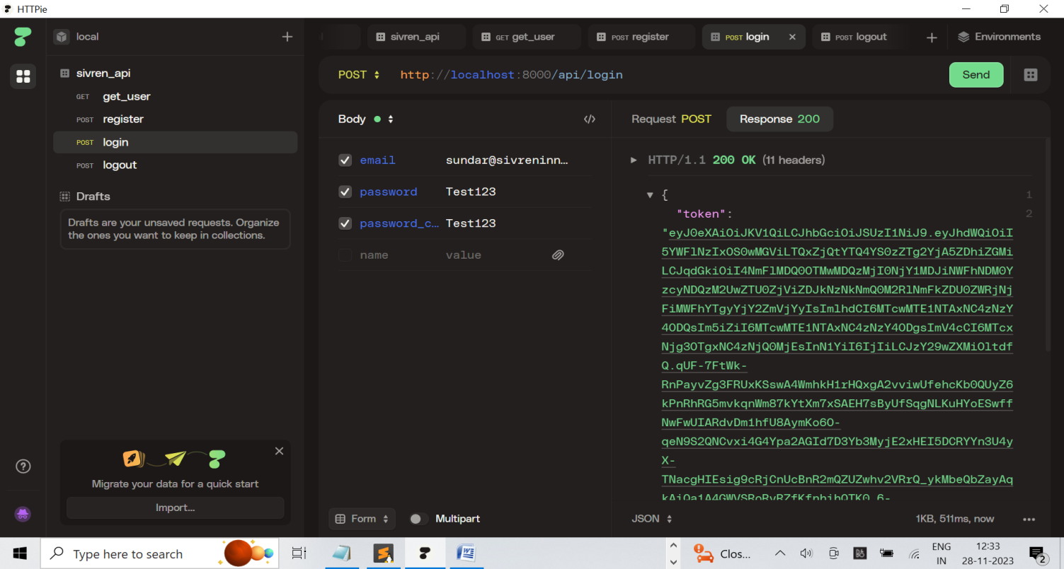

API – register | http://localhost:8000/api/register
Method | POST
API | Public API
Param | name  email  password  password_confirmation

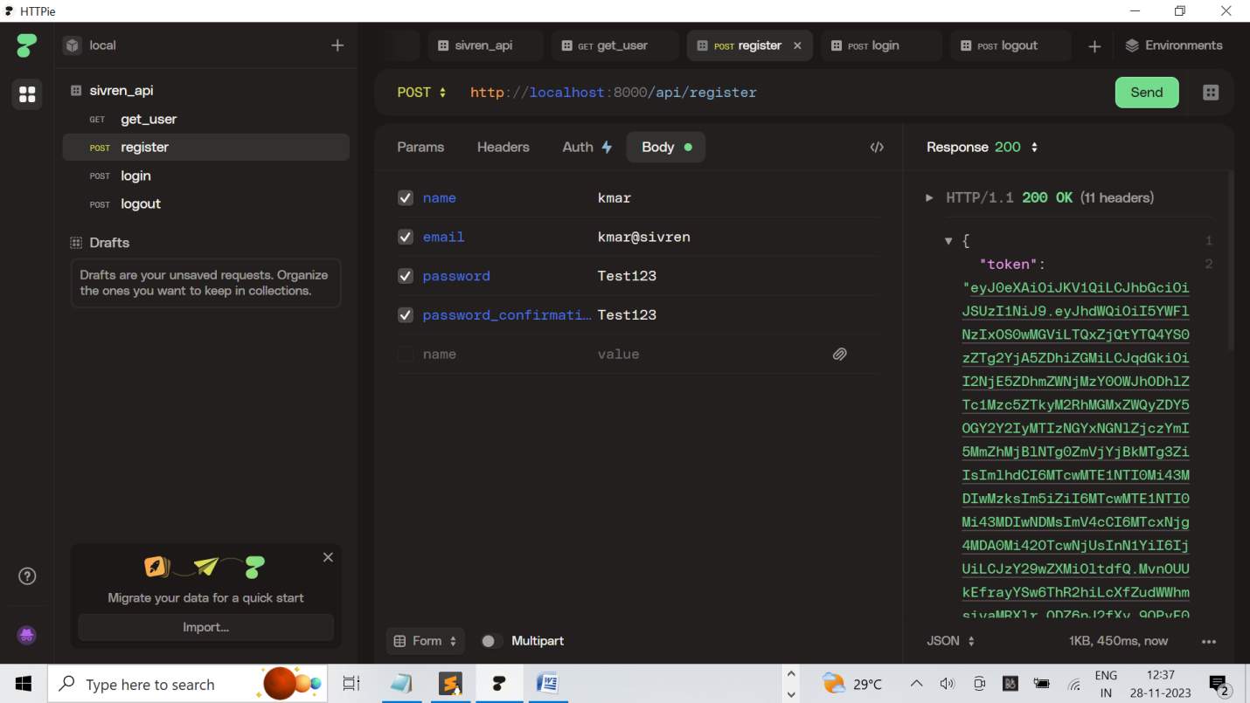

API – logout | http://localhost:8000/api/logout
Method | POST
API | Private API (token required)
Headers | Authorization Bearer <<token>>
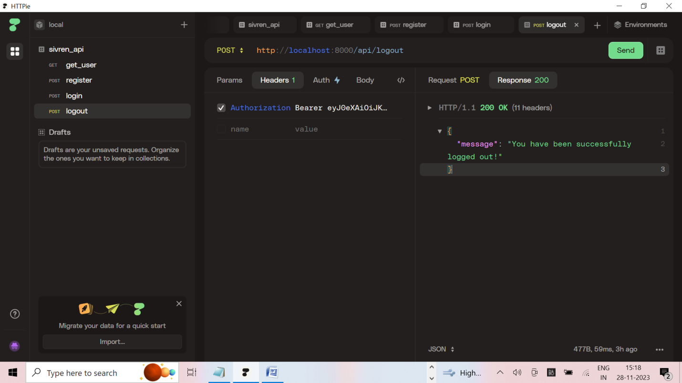

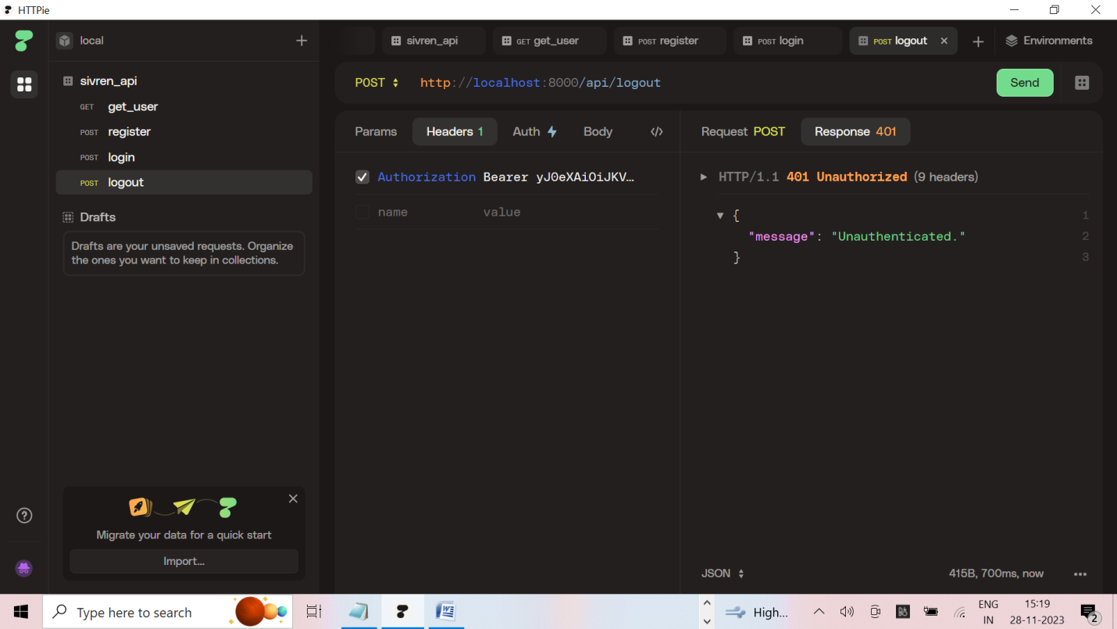
If token is wrong we get Unauthenticated message
API – user | http://localhost:8000/api/user
Method | GET
API | Private API (token required)
Headers | Authorization Bearer <<token>>
Desc | Get user details (login user)

